SMART BUTTON
SPECIFICATION

VERSION：v1.0
DATE：2017-01-14

1. Introduction
1.1 Product Overview
Smart button is a new portable intelligent shopping hardware in 2016 launched . through it you can buy your favorite products by a single press key. Smart button through our App network settings, preferences and select merchandise. It can take place anywhere in the home, when you need to buy, only need to click a single bond, smart button can bring one key shopping experience, then wait for the product "fly" to your home, without having to go downstairs to open the site to buy.
This product is widely used in fast moving consumer goods industries, such as fast-food industry, beverage industry, daily necessities, etc., it can also be used to quickly call the service industry, such as bottled water, sending gas and so on, so as to create the extreme simplicity of consumer shopping environment and more for the convenient life experience.
1.2 Key Features
Smartconfig：Ogemray develops a fast WIFI network configuration in STA mode (terminal mode), WIFI terminal in the state can receive mobile phone APP Smartconfig sent, the router name and router password GUID information.
Guide: Globally Unique Identifier refer to a backend server identification information to identify the type of business setting, in order to determine the information content of the communication and information between the device and the server.
1.3 Functions
- Smartconfig technology, quick connection.
- quick order place
- Cancel order
- One-button Customer Service
- Regularly reported to work status
- Rechargeable battery design
- Factory settings

2. Specification

2.1 Parameter
Power Supply
Power supply | A rechargeable lithium polymer battery
Lithium battery model | 502025
Lithium battery model | 3.7V 200mAh
Charging interface | Micro USB 2.0
Charging voltage / current | 5.0V 200mA
Charging time | About one hour
Total power consumption / energy consumption | Static power consumption in standby：<0.1mW
Total power consumption / energy consumption | Working power consumption: <10 joules / second,
The number of operations (taking into account the factors of self-discharge of the battery) | About 500 times under a single operating @ lithium battery is full charged
Wireless connection
communication method | WiFi 2.4G
antenna | Embedded antenna
WiFi working mechanism | STA mode
Security Mechanism | WPA/WPA2－PSK/WEP
Output Power (antenna input) | 802.11b:18dBm;11g:15dBm;11n:14dBm
channel | 1-11 (North America); 1-13 (Europe and China); 1-14 (Japan)
Network configuration | Fast connection configuration based Smartconfig
Transmission distance | Interior: 50 m, outdoor: 80 meters (varies with the environment)
Internet connection
Sleep Mechanism | Deep Sleep
Wake-up mechanism | Key operation or periodic self-activated
Wake-up time and the connecting network | Typically 15 to 20 seconds
Information report | Key Action Status
Information report | Battery charge status
Information report | Network connection status
Parameters
Physical Dimensions | 52x52x10mm
shell material | ABS
Key parameters | Touch of a button * 2
Led Light | 1 * blue LED, 1 *red LED
sound | buzzer
Weight (bare weight, without packaging) | 23g±5%
Working Environment
a fixed way | Tackiness
Working temperature | -5~45℃
Humidity | 20~80% (Non-condensing)
storage temperature | -10~50℃

2.2 Product Reference
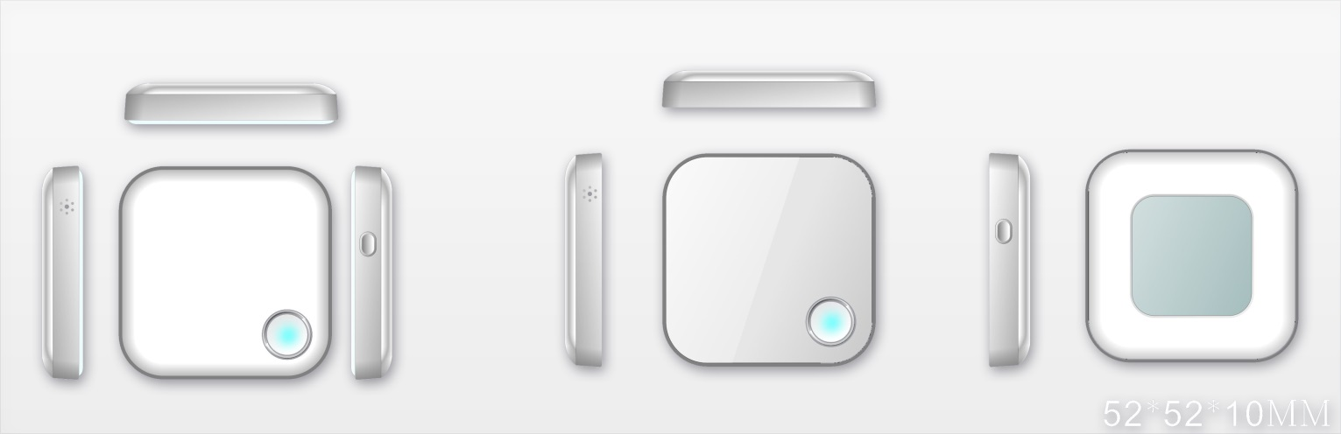
Note: Refer to the product image is not affixed to any product stickers.

3. Notification
- non-random changes in the product structure of components, structures and related electrical circuit element model specifications and parameters.
- After the battery is fully charged the charger should be unplugged to avoid accidents.
- If product fails, you should immediately contact professional service or related persons of the company.

4. Disclaimer
This specification is a detailed description of the company produced a series of product specifications, please carefully read and fully understand the detailed product specifications.
Other relevant information on our product information statement within this specification, specifications, pictures, or links do not provide any guarantees, use of risk with the user.
The Company solemn statement of the present specification, or other relevant information without any implied warranties of merchantability or guarantee commercial contracts, the information contained in the job operation only, and product use guide, not as a basis or any other contract or supplementary liability .
We make reasonable efforts to this document contains accurate and up to date information. However, the Company reserves the right without notice, at any time to update or modify the content and related information without prior notice.

